TECHNICAL PROJECT REPORT
Title of Invention / Project:
Multipurpose colour changing lamp and pot

Team Members / Inventors:
S.No. | Name | Department | Designation | Mobile | E-Mail
1. | Tarunpreet singh | CSE | Student | 8837738897 | tarunarora6029@gmail.com
2. | Khushal Thakur | ECE | Mentor | 9646030764 | khushal.thakur@cumail.in
3. | Anshul Sharma | ECE | Mentor | 9478697475 | anshulsharma.ece@cumail.in
4. | Kiran Jot Singh | ECE | Mentor | 9463909689 | kiranjotsingh.ece@cumal.in
5. | Divneet Singh Kapoor | ECE | Mentor | 9878422653 | divneet.ece@cumail.in
Section – 1 (IPR Related)
Brief Abstract
The colour changing LED lamp cum pot can be used as a source of light as well as for decorative purposes. The colours can be changed as per the surroundings to get mesmerizing effect. The lightening system is controlled with remote and can be controlled over a long distance. The system is water proof and can be easily cleaned. The maintenance costs are negligible. It can be used for people who have certain eye disorders who cannot see all the colours. They can set the colours as per their comfort. This product can be used by patients who undergo eye operations. They require dim lights of blue/green colours which can be accessed through remote. Further this is customisable product. Music system can also be incorporated to it. It will provide soothing effect to the anxiety patients.

Existing state-of-the-art and Drawbacks in existing state-of-the-art
(Brief background of the existing knowledge)
S. No. | Existing state of art | Drawbacks in existing state of art
1 | tri-color, white light led lamps  US6686691B1 | The lamps is using three colors to generate white color, but each individual color cannot be accessed.

Novel/Additional modifications that you can propose to improve upon drawbacks
- Music system can be embedded.
- Single colour can be accessed.
- Water can be added to use as aquarium.

Advantages
- Can be used by eye patients after the surgeries.
- Remote controlled system accessed over long distance.
- Provide soothing effect to the anxiety patients.
- Can be used as decorative piece.
- Low maintenance.
- Customisable.
- Music system can also be embedded.

Section – 2 (Real Project)

Material
- 50 gallon glass pot. INR 450
- Non breakable stones. INR 120
- Cotton candy leaves. INR 80
- Led strip. INR 220
- Adapter (12v) INR 80
- Remote (embedded Bluetooth control) INR 40
- Flower bouquet INR 150

Circuit Diagram

MATERIAL PICTURES
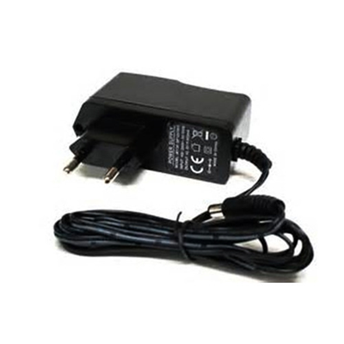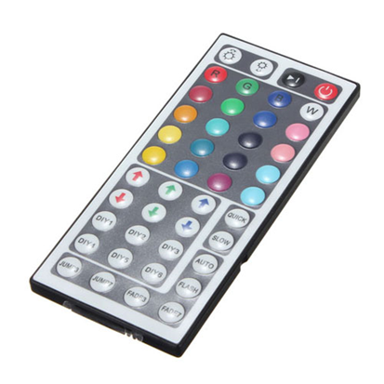
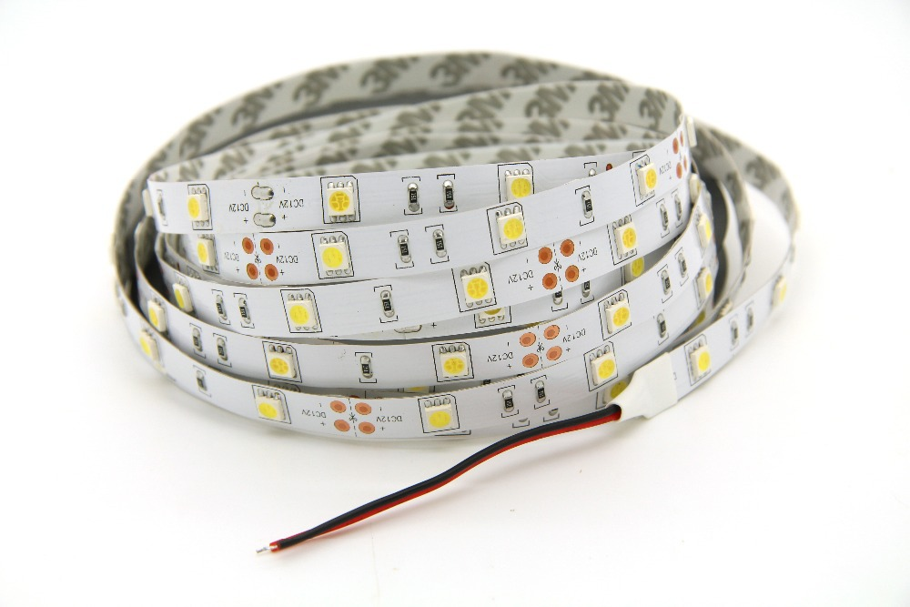

PROJECT

